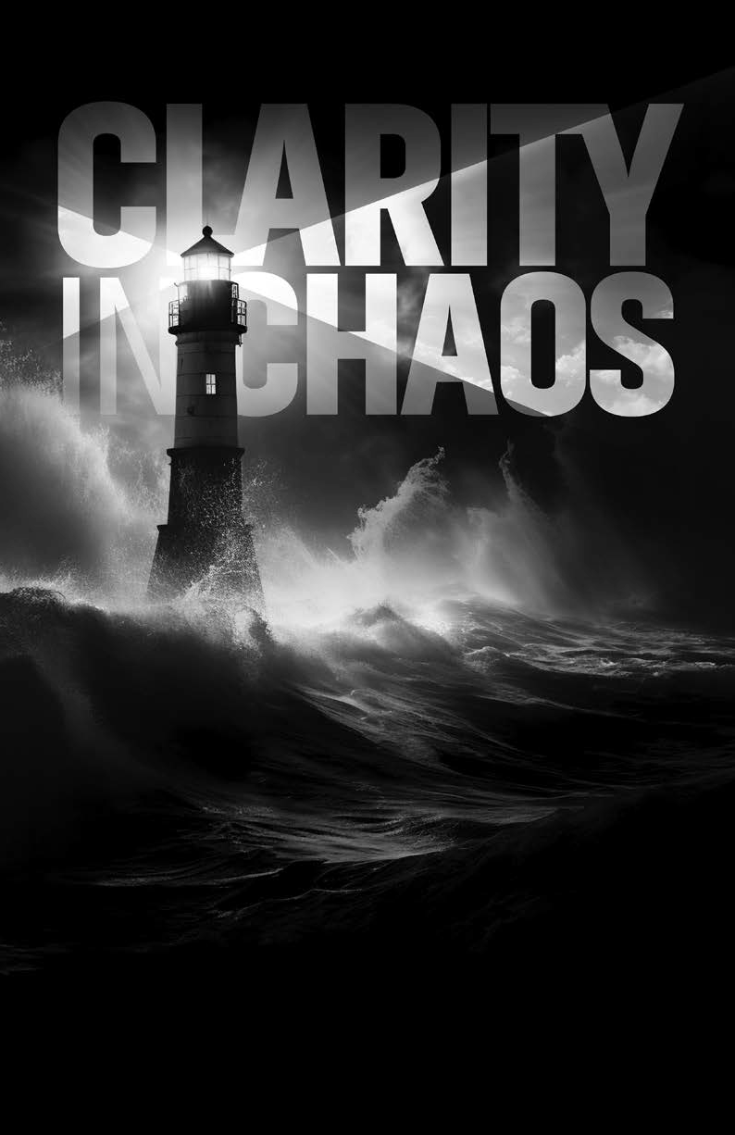

RELIGIOUS LIBERTY OFFERING
JANUARY 10, 2026

Give your offering online at
adventistgiving.org/events/parl2026

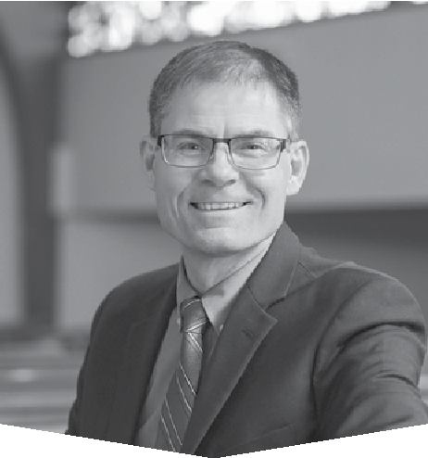

BY PASTOR
Shane Anderson
Shane Anderson has been the lead pastor of Pioneer Memorial church on the campus of Andrews University since 2023.
His passions in ministry include helping others to know Christ personally, the study and sharing of Bible prophecy, and Christian apologetics. He has written for
a variety of publications both foreign and domestic, and he’s currently a columnist for the Adventist Review. He is the author of the book How to Kill Adventist Education (and How to Give It a Fighting Chance!).

Clarity Within Chaos

Staying Spiritually Focused in a Politically Confusing World

uring the past 10 years the political scene in the United States has often radiated turmoil, at
D
times seemingly 24 hours a day. Both Democrat and Republican leaders will readily concede this point
(although their agreement as to the source of that turmoil may be more difficult to find!). Whatever one’s personal political leanings, few of us would describe the political landscape of the past decade as “orderly and peaceful.”
This raises an important question: What is a thoughtful Christian to do when faced with political pandemonium? We cannot simply ignore it, for the Bible makes it clear that politics will play a progressively pivotal role in the end of time. So how can we maintain a Christ-centered spiritual focus in a world increasingly blurred by political chaos?
Fortunately, the Bible is no stranger to such chaos. In fact, some of the most heroic biblical figures lived in times of tremendous political upheaval. The prophet Daniel was just such a person. In the Bible book that bears his name, in the sixth chapter, we find a powerful story that reveals four key lessons on how to stay spiritually focused in chaotic political times.

LESSON 1: GOODNESS, RESPECT . . . AND PERSECUTION?
Daniel 6 begins with a king named Darius cooking up chaos in the government of a freshly conquered Babylon:
“It pleased Darius to appoint 120 satraps to rule throughout the kingdom, with three administrators over them, one of whom was Daniel. The satraps were made accountable to them so that the king might not suffer loss.
“Now Daniel so distinguished himself among the administrators and the satraps by his exceptional qualities that the king planned to set him over the whole kingdom. At this, the administrators and the satraps tried to find grounds for charges against Daniel in his conduct of government affairs, but they were unable to do so. They could find no corruption in him, because he was trustworthy and neither corrupt nor negligent. Finally, these men said, ‘We will never find any basis for charges against this man Daniel unless it has something to do with the law of his God’ ” (Daniel 6:1-5).*
There are few stories in human history that start as strangely as this! Darius, ruler of the Medo- Persian Empire, had only recently conquered the neo-Babylonians. In a master stroke of warfare, he had vanquished their capital by diverting the vast Euphrates River and leading his armies through its now-dry riverbed and under the city’s walls. And then stunningly, with Medo-Persia undoubtedly overflowing with nationalistic pride, Darius does the unthinkable: He brings one of the conquered empire’s top political leaders—Daniel—and begins preparations to make him a top political leader in the conquering empire.
Astonishing! Often the conquering government in those days would simply execute all the conquered political leaders and replace them with their own. But King Darius thought twice when it came to Daniel. There was something extraordinary about him. Daniel was not a Babylonian or a Mede or a Persian, and he shared few of those empires deeply held religious and political beliefs. Yet Daniel had served Babylonian kings and now the Medo-Persians with integrity and effectiveness.
Consequently, Darius could not resist the temptation to place him in high office himself, which soon led to great difficulties . . . for Daniel!
All of which brings us to a first lesson for how we can stay spiritually focused, even in chaotic political times:

Being a good citizen who respects the government does not guarantee freedom from difficulties or persecution. Be good and respectful anyway.

Daniel was all too familiar with political chaos and the difficulties it could bring. He had seen the
government of his home country in Palestine deteriorate and finally be conquered by the Babylonians. While holding high office in Babylon, he had seen firsthand the political gyrations of King Nebuchadnezzar. Nebuchadnezzar was a brilliant leader who was nonetheless prone to wild flights of ego-driven fancy
that at times threatened to derail the empire—and to destroy Daniel and his closest friends in the process. And now Daniel is about to be thrust into potential political chaos again, with 120 satraps gunning for him and a new king that would prove to be as susceptible to flattery and selfishness as Nebuchadnezzar was. If ever there was an excuse for Daniel to become cynical or disrespectful, surely this was it!
But incredibly, Daniel does not do this. He refuses to become rude or ill-mannered. He does not bad-mouth the king, either to his face or behind the scenes. And though humanly speaking, he had grounds to do so, Daniel apparently makes no attempt to undermine the Medo-Persian government—something that, given the initial power the king gave him, would likely have been easy to do. Instead, Daniel does the seemingly impossible: He serves the Medo-Persian government with integrity and respect. He becomes a good citizen. He executes his work skillfully, serving the empire’s administration with courtesy and civility, knowing full well it could turn against him.
How different from how some Christians today respond to political adversity! Today many Christians, when confronted with political directions they disagree with, become abusive and disrespectful. Politicians are called derogatory names. Social media posts become pathways for scornful, belittling comments. Previously decorous Christians repeatedly become sharp, cutting, and cynical.
Daniel’s example makes it clear that disagreement with political decisions—even profound disagreement, as Daniel undoubtedly had with both the Babylonian and the Medo-Persian governments—should not lead us to disparage or disrespect political leaders. While there will be times (as we shall soon see in the life of Daniel) when pushing back against government decisions is essential, goodness and respect should remain the order of the day.
Six hundred years after Daniel’s ministry, Jesus would command His followers to “love your enemies, do good to those who hate you, bless those who curse you, pray for those who mistreat you” (Luke 6:27, 28). As Daniel’s life foreshadowed, following this command not only tends to build bridges in divisive times. It also enables Christ to elevate us above the muck and chaos of lowbrow political maneuverings, keeping our eyes firmly focused on Him and His agenda for the world.
Speaking of which:

LESSON 2: AVOIDING A FATAL COMBINATION
A second lesson on staying spiritually focused during political chaos is found in Daniel 6:6-9:
“So, these administrators and satraps went as a group to the king and said: ‘May King Darius live forever! The royal administrators, prefects, satraps, advisers and governors have all agreed that the king should issue an edict and enforce the decree that anyone who prays to any god or human being during the next thirty days, except to you, Your Majesty, shall be thrown into the lions’ den. Now, Your Majesty, issue the decree and put it in writing so that it cannot be altered—in accordance with the law of the Medes and Persians, which cannot be repealed.’ So King Darius put the decree in writing.”

A second lesson for keeping spiritually focused in chaotic political times is this:

State-enforced religious observance inevitably leads to persecution. Christians must therefore stay relentlessly focused on preserving religious liberty.

Can you imagine if a law like the one King Darius signed was attempted in the United States today? What if a sitting president issued an executive order requiring everyone everywhere in the nation to pray to him and him alone, with noncompliance resulting in death? Such a president would be opposed by forces both inside and out of the government faster than you can spell “impeachment”!
And how come? The answer is clear: because many Americans still believe that church and state are to be officially separate. From the time of the Founders till now, it has been largely recognized that when a government uses the rule of law to enforce religious practice—either by stopping religious observance or enforcing religious observance (or, as in Daniel’s case, both)—it leads to discord, rebellion, and, ultimately, persecution.
But alarmingly, recent events indicate that a disturbing number of Christians, apparently taking a page from the satraps of old, are having second thoughts about maintaining a wall of separation between
church and state. The disturbing decline of national morality, such Christians say, and the seemingly endless inroads that particularly sexual immorality has made into education, media, and daily discourse, mean that drastic measures must be taken. They further allege that the state must begin to enforce moral reform, even if it means mandating certain religious practices be performed by both religious and irreligious citizens. In short, they say, it is time to return America to its Christian roots.
It is undoubtedly true that Christians are called by God to (for instance) vote as He would vote if He were in their shoes. Christians furthermore have historically formed an indispensable part of the conscience of our nation, praying and working ardently for its protection and success. And we must continue these things, helping our country to maintain its basic moral fiber by all appropriate means.
But that’s the key phrase: “by all appropriate means.” For history has shown repeatedly that there are highly inappropriate means by which the church can seek the power of state to enforce its agenda.

AVOIDING THE INAPPROPRIATE
To avoid engaging in inappropriate means, Christians today would do well to remember at least three points.
First, America was never founded as a Christian nation—in fact, only a handful of the Founders were what could be called evangelical Christians. The majority instead were deists. Deists’ religious views varied. But in general, a deist believed:

- in a divine Creator (not to be confused with the biblical Creator of the book of Genesis, and certainly not with Jesus Christ).
- that the Creator has a will, which most deists saw as essentially “natural law,” which included in essence the last six of the Ten Commandments, among various other sources of moral guidance.
- that at the end of our lives we will be called to account before God for how we lived.

Thus, while deism had a pronounced moral element, distinctively Christian teachings such as sin, the fall of humanity, salvation through Christ, the call to share one’s faith, etc., were seen as incompatible with it.
This leads to some important realizations. For instance, the Declaration of Independence’s famous phrase “We hold these truths to be self-evident, that all men are created equal, that they are endowed by their Creator with certain unalienable Rights” is classic deist language. It is not a reference to the Christian conception of the biblical Creator or to Jesus Christ. And while the Founders were friendly to Christianity (particularly in its Protestant form), they were adamant that no specific religion should ever be mandated by our Constitution.
This is why Founder John Adams could honestly say in the Treaty of Tripoli in 1797 that “the Government of the United States of America is not, in any sense, founded on the Christian religion.”
Consequently, anyone trying to return the United States to its Christian roots is attempting an impossibility. You cannot return to a country, where that country has never been. And if a Christian continues the attempt anyway, he or she may be unwittingly laying the groundwork for the very thing the Founders were seeking to avoid religious observance—and inevitably, religious persecution—enforced by the power of the state.
Second, Christians must remember that lasting, positive change in society comes primarily through evangelism and discipleship, not through politics or government programs. No, Christians are not to oppose all government programs. Some are indeed useful and deserve our support. But we must never forget that the government ultimately relies on the force of law, and force can never bring lasting transformation in the heart. Christ instead invites—not forces but invites—all who are willing to do so to surrender to Him, and by His grace begin to be transformed more and more into His image. Such transformed lives are a source of tremendous joy to those that have been thus set free! And from a civic perspective, they have also proved to be the bedrock of lasting, positive societal change. Consequently, the fact that so many Christians today are looking to use the power of the state to compel lasting societal change is a sign, not of resourcefulness, but of failure: the failure to fulfill the Great Commission and to make mature, loving disciples of Jesus Christ.
Third, Christians must remember that sinners have rights, including the right to make bad decisions. True, these rights have limitations. Citizens of the U.S., for instance, are not free to harm or kill or steal from other citizens (and they have no right to force Christians to promote immorality in Christian institutions or in Christians’ personal lives or homes—more on this in Lesson 3). But Christians must nonetheless be exceedingly careful in how and to what extent they seek to enforce personal morality on other citizens. Religious liberty, including the liberty to not be religious, must be maintained if true freedom is to endure in our nation.
Obviously, preserving this wall of separation between church and state can be complex and difficult. Maintaining a society that is sufficiently moral to preserve public peace, while at the same time preserving citizens’ rights to not be moral (within constitutional limits) if they so choose, is a balancing act like no other. May God grant us and our government leaders the insight to encourage a sufficiently robust moral standard while avoiding a theocracy.

LESSON 3: A RESPECTFUL LACK OF CONCESSION
A third lesson for keeping spiritually focused in chaotic political times is found in Daniel 6:10, 11:
“Now when Daniel learned that the decree had been published, he went home to his upstairs room where the windows opened toward Jerusalem. Three times a day he got down on his knees and prayed, giving thanks to his God, just as he had done before. Then these men went as a group and found Daniel praying and asking God for help.”
The third lesson is this:

When religious liberty is threatened, Christians must refuse to personally compromise on biblical principle and practice.

Daniel’s example here is surely one of the most extraordinary in all Scripture. He knew full well the serious nature of the king’s decree and was undoubtedly familiar with the carnage hungry lions could inflict. Yet he nonetheless proceeded to do exactly what he had always done: look to God, in prayer, three times a day— and he did so in highly visible fashion, at the sill of his upstairs window.
There is no hint of compromise here! The king’s arrogance and resumption were public challenges to God’s sovereignty. Daniel consequently knew that anything less than unbroken continuation of his previous devotional life would be viewed as agreement with this royal sacrilege. So Daniel prayed—not once or twice a day, but three times, just as before. Daniel prayed—not in a closet or under his bed, but at the open window, just as before. Daniel prayed—not to King Darius, a mere mortal, but to Jehovah, the great God of heaven and the master of all earthly kingdoms, just as before. It was and remains one of the most striking examples of unrelenting faithfulness to God! And it reminds us that respectful, uncompromising obedience to God and His Word keeps us rightly focused, even in chaotic times.
It also illustrates clearly at least two additional truths. First, being respectful of political leaders does not mean we never disagree with them. While there’s not the slightest whiff of hostility or verbal disrespect in Daniel’s attitude toward the king or the satraps, he nonetheless openly disagreed with them. Christians today may at times need to do likewise.
Second, it is tempting to see Daniel’s continued prayers at his window as an endorsement of civil disobedience—and indeed, there is a measure of support here. Civil disobedience, defined by the Brittanica Dictionary as “the refusal to obey the demands or commands of a government or occupying power, without resorting to violence or active measures of opposition” has happened many times in U.S. history. And as Daniel’s story confirms, there are times it is called for. In recent memory, for instance, the U.S. government has exerted significant public pressure on Christians and their institutions to promote sexual morals that violate Scripture. Christians’ response to such pressure must be a respectful, clear, and public “No.” Furthermore, we know that a day is coming when we will just as firmly need to disobey the government’s command to observe a false Sabbath. Sometimes nothing less than public dissent will do.
But Daniel’s story also shows that those times are most likely rare. In more than 60 years of civic service, the Bible records Daniel publicly disobeying the law of the land only once, right here in Daniel 6. Apparently, on all the other occasions Daniel disagreed with public policy (and there certainly must have been many such times!), he maintained high moral standards while using other, less-public means to deal with the problem. We must therefore pray for God’s wisdom to know when to head for the upper room window to pray and when to pursue uncompromising obedience to God through other, more discreet ways.
But back to our story:

LESSON 4: HOPE IN THE DARK TIMES
Daniel’s boldness inspired his enemies to take swift action. His prayers were reported to the king—and immediately Darius panicked. Daniel 6:14 tells us that “when the king heard [of Daniel’s prayers], he was greatly distressed; he was determined to rescue Daniel and made every effort until sundown to save him.” But not even a king was allowed to reverse a Medo-Persian law, no matter how foolish its unintended consequences turned out to be. And with profound anguish and regret, Darius ordered Daniel to thrown into the lions’ den. “May your God, whom you serve continually, rescue you!” the king called to Daniel. And after sealing the entrance to the den, Darius retired to a sleepless night.
But all who are familiar with the story know that it is far from over! After what must have seemed like the longest night of his life, King Darius rushed to the lions’ den at the first hint of dawn. “Daniel, servant of the living God,” he called out in verse twenty, “has your God, whom you serve continually, been able to rescue you from the lions?” The Bible records the joyous response:
“Daniel answered, ‘May the king live forever! My God sent his angel, and he shut the mouths of the lions. They have not hurt me, because I was found innocent in his sight. Nor have I ever done any wrong before you, Your Majesty.’ The king was overjoyed and gave orders to lift Daniel out of the den. And when Daniel was lifted from the den, no wound was found on him, because he had trusted in his God” (verses 21-23).
And . . . cut! Many times, the story ends right there. Daniel is now safe, his body is unscathed, and God has rewarded the faithfulness of His servant—a genuinely good ending if ever there was one, correct?
But there is one final part of the story that holds a valuable lesson, particularly regarding the fast-approaching end-time religious liberty crisis. After Daniel and the king are reunited, Darius made the following proclamation “to all the nations and peoples of every language in all the earth”:
“May you prosper greatly! I issue a decree that in every part of my kingdom people must fear and reverence the God of Daniel. For he is the living God and he endures forever; his kingdom will not be destroyed, his dominion will never end. He rescues and he saves; he performs signs and wonders in the heavens and on the earth. He has rescued Daniel from the power of the lions” (verses 25-27).
Darius here reveals a fourth and final lesson for how to keep a clear spiritual focus even in chaotic political times:

The coming battle over religious liberty will be difficult. But it will also be the means of
transformation for thousands—and that is cause for celebration!

It seems safe to assume that the average Jew in Babylon, upon hearing Darius’ initial prayer decree, would have never dreamed that in a matter of hours he would be confessing to the world that Jehovah is the living God! Yet that is precisely what happened. What seemed at first to be one of the darkest hours for God’s followers instead proved instead to be the point of profound reversal by one of the most unlikely candidates for God’s kingdom.
Today Seventh-day Adventists have been blessed with an abundance of knowledge about the end of time. And while most find this information inspiring, it has also made others nervous or even fearful. Revelation 13, for instance, portrays a conflict of epic proportions, promising a cosmic battle between Christ and Satan that will culminate in a global choice: Will we receive the mark of the beast, worshipping in his way on his day, or will we receive the seal of God, worshipping in His way on His day? The beast powers will attack religious liberty as never before, and ultimately that liberty will vanish.
Those days will indeed be difficult ones.
But the story of Darius’ change encourages us with a profound reminder. Regardless of how dark the last days will be, they will also be a time of widespread conversion to Christ, the likes of which the world has never seen.
Revelation 18:1 speaks of the gospel of Christ going with such force in those days that the entire planet is lit up with its splendor. Furthermore, in The Great Controversy, pages 611 and 612, we find the following encouragement:
“The great work of the gospel is not to close with less manifestation of the power of God than marked its opening Servants of God, with their faces lighted
up and shining with holy consecration, will hasten from place to place to proclaim the message from heaven. By thousands of voices, all over the earth, the warning will be given. Miracles will be wrought, the sick will be healed, and signs and wonders will follow the believers…Now the rays of light penetrate everywhere, the truth is seen in its clearness, and the honest children of God sever the bands which have held them. Family connections, church relations, are powerless to [stop] them now. Truth is more precious than all besides. Notwithstanding the agencies combined against the truth, a large number take their stand upon the Lord’s side.”

So let us not dread the coming crisis! Though it will be difficult, it will also be the finest hour of God’s church! Thousands upon thousands will choose Jesus. Baptistries, rivers, and the ocean itself will undoubtedly all be used to keep up with the flow of baptisms as new disciples stream into God’s kingdom. People from all walks of life will leave Satan’s ranks and join heaven’s at the prophetic eleventh hour. It will be, quite simply, one of the most incredible times to be alive in all of earth’s history! I want to be there! Don’t you?

CLARITY CAN BE FOUND
We do indeed live in chaotic political times. But there’s no reason to let the chaos cloud our focus on God and His Word. We can instead let the lessons of Daniel and Darius remind us that spiritual clarity can still be found. And just as God has been faithful in the past, He can be trusted to carry us safely through the crisis that lies ahead. May God’s Spirit fill and guide us as we navigate these turbulent last days for His glory.

* Bible texts are from the Holy Bible, New International Version. Copyright © 1973, 1978, 1984, 2011 by Biblica, Inc. Used by permission. All rights reserved worldwide.



RELIGIOUS LIBERTY OFFERING
JANUARY 10, 2026

